# Project Title:

## Image to Grayscale Converter using NumPy and PyQt

Anurag Paul (22MID0080), Kinjal Ghosh (22MID00331), Pratik A Shah (22MID0281), Dhanushvanth VH (22MID0063)

### 1. Abstract

This project implements a simple yet effective **desktop application** that converts any given colour image into its grayscale equivalent using **NumPy-based pixel-level computation**.  
The application is developed with **PyQt5** for the graphical user interface (GUI) and relies solely on **NumPy** for image data processing — without using any specialized image-processing libraries such as OpenCV or Pillow.

The program supports both **file selection** and **drag-and-drop** image loading, displays the **original** and **grayscale** images side by side, and allows the user to **save** the generated grayscale image.  
The objective of this mini project is to demonstrate how basic **matrix and numerical operations** can be effectively utilized for image manipulation.

### 2. Project Objectives

* To build an intuitive GUI application for converting colour images to grayscale.
* To perform grayscale conversion purely using **NumPy operations** (no OpenCV/Pillow).
* To enable user interaction through **PyQt** with image loading, visualization, and saving features.
* To understand how pixel data can be accessed and manipulated at the **array level** using NumPy.

### 3. Tools and Technologies Used

|  |  |
| --- | --- |
| **Component** | **Technology / Library** |
| Programming Language | Python 3 |
| GUI Framework | PyQt5 |
| Image Processing | NumPy |
| Development Environment | VS Code / PyCharm / IDLE |
| Supported Formats | PNG, JPG, JPEG, BMP, GIF |

### 4. Project Approach

The project integrates GUI design with numerical computation using the following layered approach:

1. **Frontend (User Interaction):**
   * Developed using **PyQt5**, providing buttons and drag-and-drop functionality.
   * Displays two image panels: one for the original image and another for the grayscale version.
   * Includes buttons for “Load Image” and “Save Grayscale”.
2. **Backend (Image Conversion Logic):**
   * The selected image is loaded as a **QImage** object.
   * Its raw pixel buffer is accessed and converted into a **NumPy array**.
   * The RGB pixel values are processed mathematically to compute grayscale intensities using the formula:  
     Gray = [0.299*R + 0.587*G + 0.114*B]
   * The resultant grayscale matrix is then converted back into a **QImage** for display.
3. **Output Handling:**
   * The grayscale image is displayed beside the original.
   * Users can save the processed image to a local directory.

### 5. Methodology

**Step 1: Image Loading**

* The user selects or drags an image into the application.
* The QImage class reads the file into memory.
* The pixel buffer is accessed using bits() and converted into a NumPy array.

**Step 2: Image Conversion**

* Each pixel’s RGB values are extracted from the NumPy array.
* A linear transformation (dot product) is applied using the weighted coefficients [0.299, 0.587, 0.114].
* The output is cast to uint8 type to form a valid grayscale image.

**Step 3: Display and Save**

* The grayscale matrix is transformed back into a QImage object for rendering in PyQt.
* The user can optionally save the grayscale image in PNG or JPEG format.\

### 6. Observations and Results

* The grayscale image produced is visually accurate and matches expected luminance distribution.
* The vertical line artifacts were initially observed due to **byte padding** in QImage data; resolved by adjusting for **bytesPerLine**.
* The NumPy-based pixel manipulation is efficient and fast even for large images.
* The PyQt interface remains responsive, supporting drag-and-drop for better usability.
* Memory consumption remains minimal since only array operations are used.

### 7. Advantages

* Lightweight and dependency-free (uses only NumPy + PyQt).
* Demonstrates direct pixel manipulation using NumPy arrays.
* Educational value in understanding color-to-grayscale transformation.
* Platform-independent and easy to extend (can add filters or color effects).

### 8. Limitations

* Does not currently handle alpha transparency (translucent pixels are ignored).
* Limited to grayscale conversion — no advanced filters yet.
* Processing speed may vary slightly for very large images due to NumPy array reshaping.

### 9. Future Enhancements

* Add support for other image effects (sepia, blur, contrast adjustment, etc.).
* Include histogram visualization of grayscale pixel intensities.
* Integrate real-time preview with sliders for brightness and contrast.
* Extend to batch image processing.
* Provide export options for different formats and compression levels.

### 10. Conclusion

This mini project demonstrates how a simple concept like **grayscale conversion** can be implemented efficiently using **NumPy’s matrix operations** integrated within a **PyQt GUI framework**.  
It successfully bridges theoretical image-processing formulas with practical, interactive visualization — making it an ideal example of numerical computing applied to real-world graphics.

The project reinforces understanding of how **RGB data is stored and manipulated**, and provides a foundational base for more advanced image-processing projects.

### 11. Output:

**Initial App:**

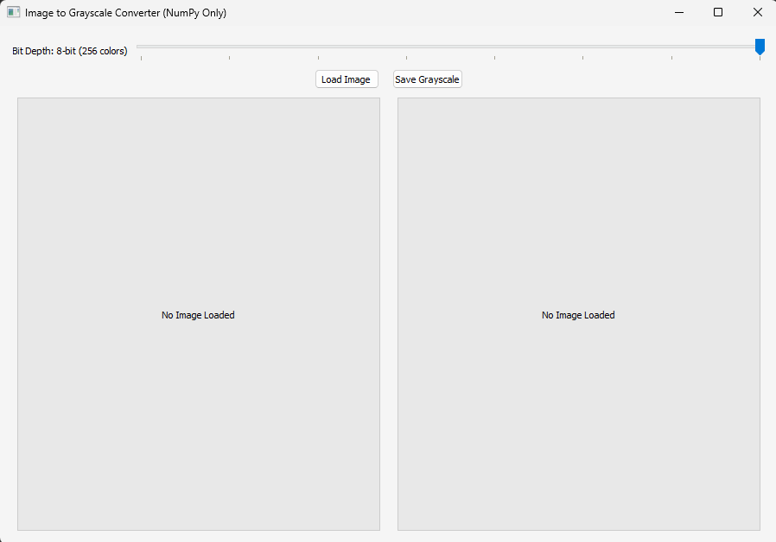

**Greyscale Conversion:**

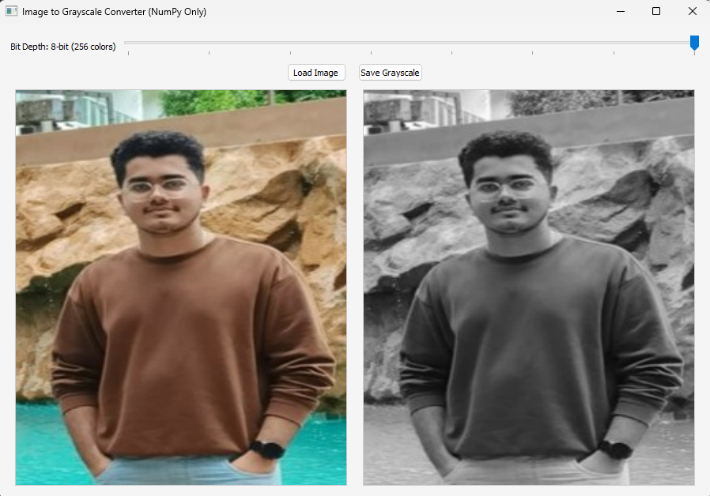

**Greyscale with Quantization:**

**Level 8 Quantization:**

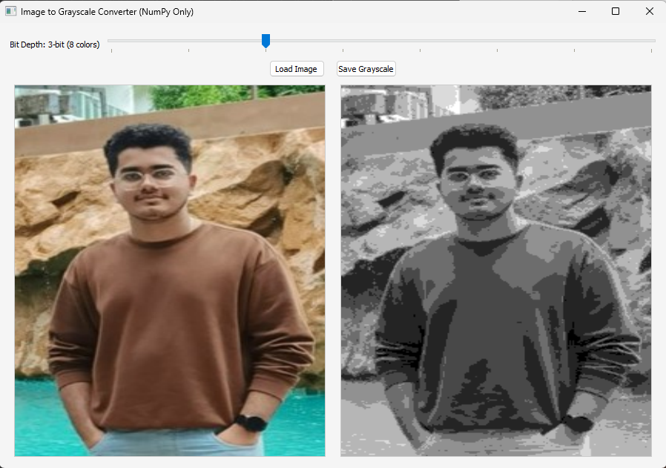

**Level 4 Quantization:**

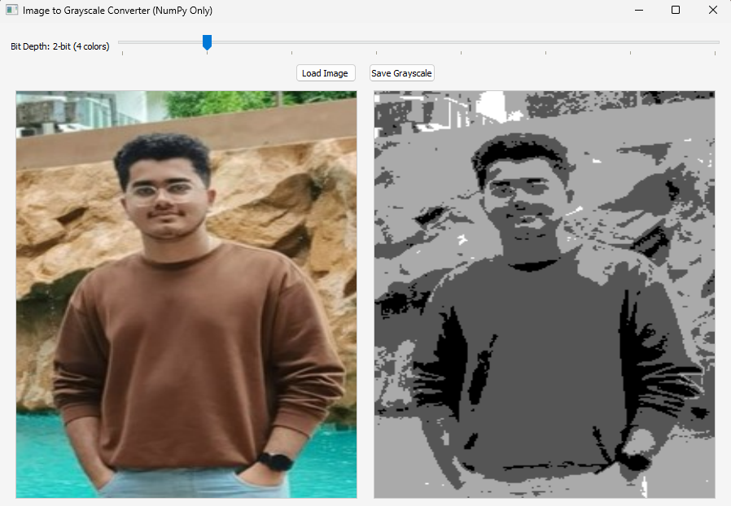

# Project GitHub Link:

**Link:** [GrayScale-Inverter-With-Quantization/Greyscale_Inverter/src/main.py at main · Anurag30032004/GrayScale-Inverter-With-Quantization](https://github.com/Anurag30032004/GrayScale-Inverter-With-Quantization/blob/main/Greyscale_Inverter/src/main.py)